**Project Plan**

**MindfulLens**

|  |
| --- |
| **Date : 08/03/2024** |
| **Version : 0.1** |
| **State : In process** |
| **Author : Andreiev Tymofii** |

#### Version history

|  |  |  |  |  |
| --- | --- | --- | --- | --- |
| **Version** | **Date** | **Author(s)** | **Changes** | **State** |
| 0.1 | 08/03/2024 | Andreiev Tymofii | Initiated document | In process |
|  |  |  |  |  |
|  |  |  |  |  |

**Distributio**

Contents

1. Project assignment 3

1.1 Context 3

1.2 Goal of the project 3

1.3 Scope and preconditions 3

1.4 Strategy 3

1.5 Research questions 3

1.6 End products 4

1.6.1 Product breakdown structure 4

2. Project organisation 6

2.1 Stakeholders 6

2.2 Team members 6

2.3 Communication 6

3. Activities and time plan 7

3.1 Phases of the project 7

3.2 Time plan and milestones 7

4. Risks 8

# Project assignment

## Context

MindfulLens is a software application designed to help individuals develop rational thinking skills. It provides a range of features aimed at promoting critical thinking, overcoming biases, and fostering intellectual growth.

## Goal of the project

The goal of the MindfulLens project is to create a user-friendly and effective software solution that empowers users to become more rational in their decision-making processes. By providing access to exercises, resources, and a supportive community, the application aims to facilitate personal growth and development in the realm of rationality.

## Scope and preconditions

|  |  |
| --- | --- |
| **Inside scope:** | **Outside scope:** |
| 1. Exercises and situation simulations to overcome biases | 1. Localization |
| 1. Vocabularies of biases, helpful theories and methods, useful sources of information |  |
| 1. Forum for user discussions and interaction |  |
| 1. Publishing news and interviews about rationality |  |
| 1. Feedback and rating system |  |
| 1. User registration, profile editing, and personalized rationality development programs |  |

## Strategy

The project will follow a waterfall approach, which involves sequential phases of development, where each phase must be completed before moving on to the next. The project will be divided into distinct stages, including requirements gathering, design, implementation, testing and deployment.

## Research questions

1. How can cognitive biases be effectively addressed through software-based exercises and simulations?

**Approach**: Conduct a literature review to identify existing research on cognitive biases and their impact. Design and implement software-based exercises and simulations targeting specific biases. Evaluate the effectiveness of these exercises through user feedback and performance metrics.

1. What features and functionalities are most beneficial for promoting rationality and critical thinking in users?

**Approach**: Survey potential users to gather insights into their preferences and needs. Conduct user interviews and focus groups to identify key features and functionalities that would enhance their rationality development. Prototype and test different feature sets to determine their impact on user engagement and learning outcomes.

1. How can user engagement and retention be maximized within the MindfulLens application?

**Approach**: Analyze user behavior and interaction patterns within the application. Implement gamification elements, such as achievements, badges, and progress tracking, to incentivize continued usage. Monitor user feedback and iteratively improve the user experience based on insights gathered from user testing and analytics.

1. What are the most common cognitive biases encountered by users in decision-making contexts?

**Approach**: Review existing literature on cognitive biases and decision-making heuristics. Collect data on user interactions and decision-making processes within the application. Analyze user feedback and performance metrics to identify patterns indicative of specific cognitive biases.

1. How do users perceive the effectiveness and usefulness of the MindfulLens application in improving their rational thinking skills?

**Approach**: Conduct surveys and interviews with users to gather qualitative feedback on their experiences with the application. Use quantitative measures, such as user ratings and completion rates, to assess user satisfaction and perceived effectiveness. Iterate on the application based on user feedback to enhance its impact and utility.

1. What are the potential barriers to user adoption and engagement with the MindfulLens application?

**Approach**: Identify potential barriers through user surveys, interviews, and usability testing. Address usability issues and interface concerns through iterative design improvements. Provide comprehensive onboarding and training materials to help users navigate the application effectively.

1. How does the implementation of personalized learning programs impact user engagement and learning outcomes?

**Approach**: Design and implement personalized learning programs tailored to individual user preferences and learning styles. Measure user engagement and learning outcomes before and after implementing personalized programs. Compare results with users who receive standard learning experiences to assess the effectiveness of personalization strategies.

1. What are the key factors influencing user satisfaction and retention with the MindfulLens application over time?

**Approach**: Track user satisfaction and retention metrics longitudinally over an extended period. Analyze user feedback and usage patterns to identify factors contributing to satisfaction and retention. Implement targeted interventions or enhancements based on insights gathered to improve long-term user engagement and loyalty.

## End products

### Product breakdown structure

# Project organisation

## Stakeholders

|  |  |  |  |
| --- | --- | --- | --- |
| **Name** | **Abbreviation** | **Role and functions** | **Availability** |
| Sachin Bhardwaj | S. Bhardwaj | WKS teacher | Tuesday 13.00 – 14.30  Friday 13.00 – 16.00 |
| Marco Meulenbroeks | M. Meulenbroeks | WAD teacher | Thursday 13.00 – 16.00  Friday 09.00 – 12.00 |
| John Wijnen | J. Wijnen | OOD teacher | Monday 13.00 – 16.00  Friday 09.00 – 12.00 |

## Team members

|  |  |  |
| --- | --- | --- |
| **Name** | **Abbreviation** | **Role and functions** |
| Andreiev Tymofii ( t.andreiev@student.fontys.nl) | T. Andreiev | Main developer |

## Communication

**Meeting with teachers:**

* Goal: to improve code or overall view of my project
* Location: -
* Frequency: -

# Activities and time plan

## Phases of the project

1. Website and desktop app
2. Algoritm

## Time plan and milestones

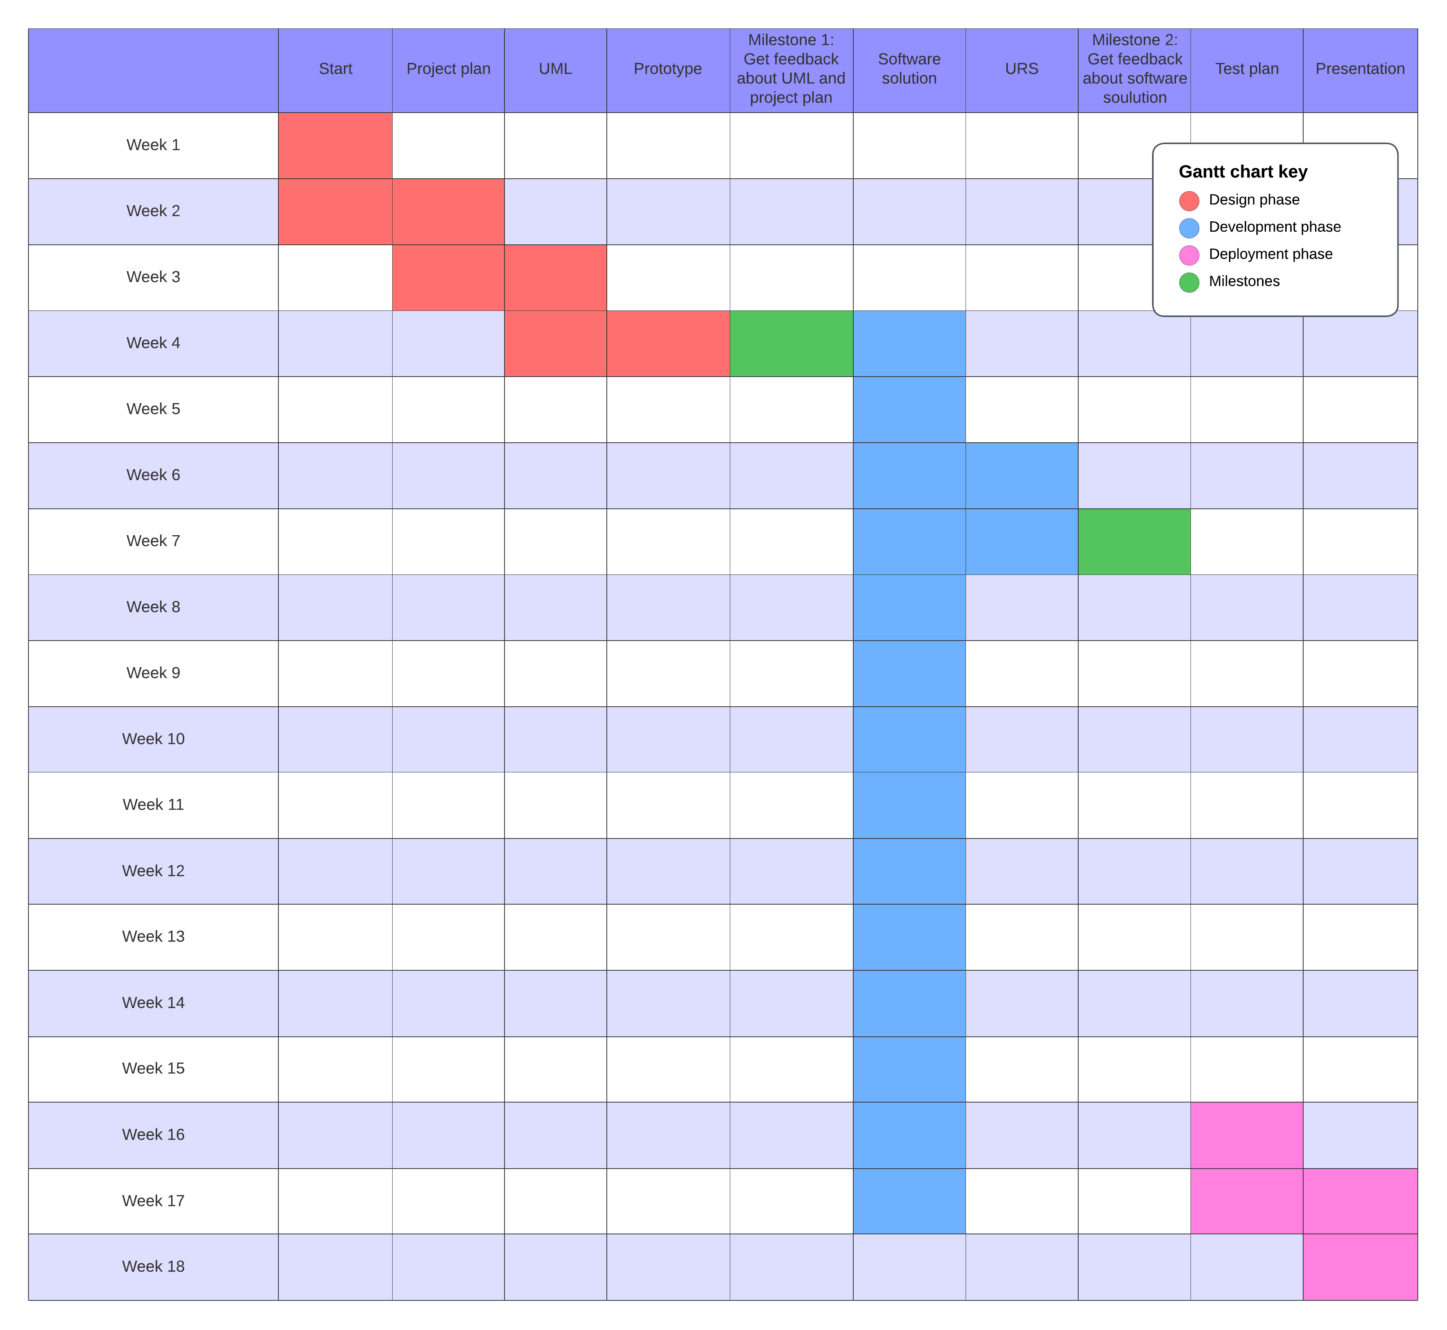

# Risks

|  |  |  |
| --- | --- | --- |
| **Risk** | **Prevention activities** | **Mitigation activities** |
| 1. Technical complexity | Conduct a technical feasibility study to assess the complexity of the project requirements. Allocate sufficient time for research and development. | Hire experienced developers or consultants with expertise in relevant technologies. Break down complex tasks into smaller, manageable components. |
| 1. Resource constraints | Estimate resource requirements accurately and allocate resources effectively. Monitor resource utilization and adjust allocation as needed. | Prioritize tasks based on criticality and available resources. Explore outsourcing options for non-core activities. |
| 1. Scope creep | Define the project scope clearly and obtain stakeholder buy-in. Document change requests and assess their impact on project scope, timeline, and budget. | Regularly review project progress against the defined scope. Obtain formal approval for any changes to scope, timeline, or budget. |
| 1. Integration issues | Conduct thorough integration testing to identify and resolve compatibility issues between system components. Use standardized interfaces and protocols where possible. | Develop contingency plans for potential integration challenges. Implement robust error handling and logging mechanisms to facilitate troubleshooting. |
| 1. User adoption challenges | Conduct user testing and gather feedback throughout the development process. Provide comprehensive training and onboarding materials to support user adoption. | Monitor user engagement metrics and solicit feedback from users to identify areas for improvement. Implement user-friendly features and interface enhancements based on user feedback. |